Ellen Dong
Longwood, FL | Lake Mary Preparatory School

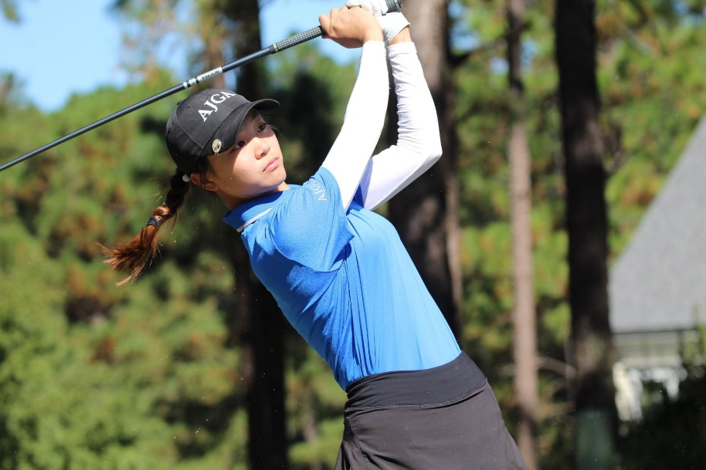
Ellen will join the Emory community this fall from Lake Mary Prep, in Lake Mary, Florida. She is a part of many extracurricular activities including the Key Club, Study Buddies, and volunteer golf ambassador for US Kids Golf and the AJGA.
Her list of golf accomplishment is long. Highlights include winning the 2020 Florida Girls’ Junior Amateur Championship with scores of 69, 73, and 71. In October 2020, she also won the AJGA Matthew NeSmith Junior Championship with scores of 76 and 68. Ellen had two other top 5 finishes in AJGA events during the summer of 2020. She helped her team win the 2019 Florida State High School Championship for 1A schools and had two 2nd place finishes individually at the state championship. Ellen’s current AJGA ranking is 50, and her JGS ranking is 126 with a -2.39 scoring differential.
Her collegiate goals including interacting with and learning from Emory’s diverse student body population and helping her team earn a bid to the DIII National Championship every year. Ellen is undecided with her major but is leaning towards business.

Heejo Hyun
Irvine, CA | Jserra Catholic High School
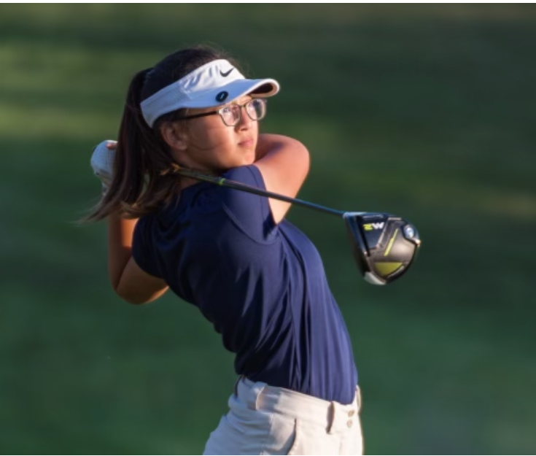
Our Emory family welcomes Heejo from Irvine, California. Heejo enjoys serving her community by volunteering in many activities. Heejo has played the flute for seven years, and she participates in the school orchestra. She shares her love of the flute by teaching children in underserved communities through local programs. She also volunteers in a leadership program called Emerging Leaders at a local elementary school.
Heejo played in over fourteen tournaments during the 2020 calendar year and placed in the top 15 four times. Some of her best scores include 65, 70, 71 and 72. Her round of 65 was a personal best, and she is looking to improve on that score in college. Heejo’s current AJGA rank is 371, and her current JGS rank is 583 with a scoring differential of 1.25. She is currently undecided with her pursuit of a major.

Sharon Mun
Suwanee, GA | Lambert High School
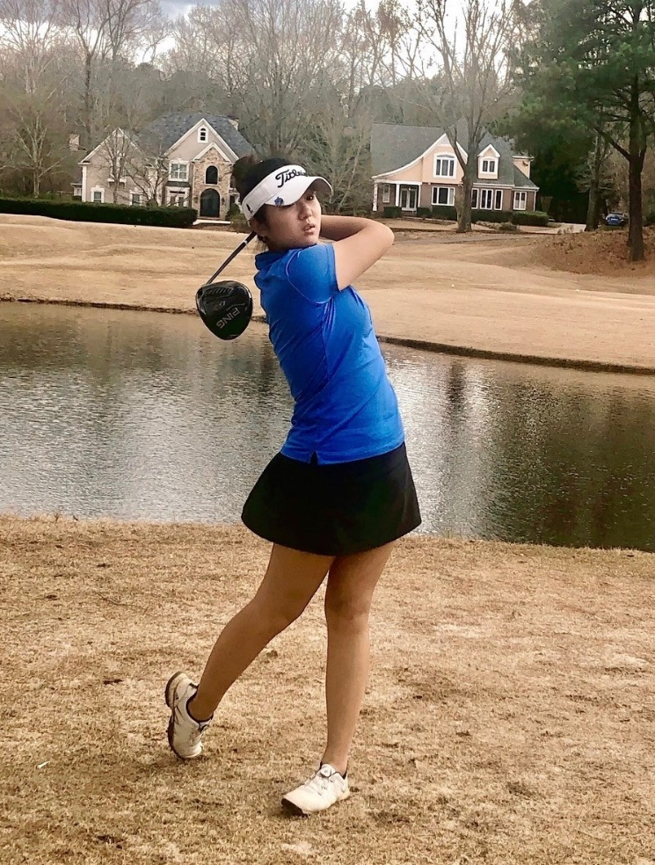
Sharon hails from just outside of Atlanta, GA. She cofounded the International Student Association at her high school which finds international and immigrant students peers that tutor and help with transitioning to a new school. In addition, she is a member of the Beta Club, where she volunteers for local clothing and food drives.
Sharon is an AJGA Scholastic All-American, and she had 4 top five finishes in the summer of 2020. In addition, she is a member of the National Honor Society. She won the HJGT event at TPC Sugarloaf with scores of 70 and 76 and the Haskins Junior Invitational with scores of 75, 78 and 74. Her current AJGA ranking is 394, and her JGS ranking is 494 with a .69 scoring differential.
Sharon would like to help her team earn a DIII National Championship bid and individually would like to contend in at least three collegiate events. She is excited about creating memories with her new team and traveling to different parts of the country for collegiate events. Sharon is interested in studying psychology, or she might pursue the pre-dental track.

